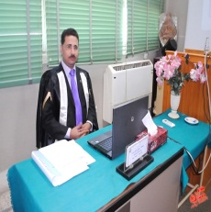
C.V
Romany Anees Mourad Boktor
Assistant lecturer, Accounting Depart., Faculty of Commerce, Asyut University, Egypt
Tel. +2 088
Mob. +201025512122
Address:.Assiut
E-mail: romany_am@aun.edu.eg

Qualifications:-
Bachelor degree in accounting, Faculty of Commerce. Assiut University, Egypt, Grade "very good with Honour Grade", June 2001
Post-graduate Studies:-
- Master degree in Accounting "Cost Accounting", july 2012, Research Title "Developing The Cost Information System to Rationalize Maintenance Decisions With Application on Misr Aluminum Company"
- Doctoral Studies in Accounting to obtain Ph.D. degree
Occupational Experiences:-
- Sep.2012-Uptil now: working as Assistant Lecturer in Accounting
Depart, Faculty of Commerce, Assuit University
- Feb.2002-Aug.2012: working as Demonstrator in Accounting Depart,
Faculty of Commerce, Assuit University, Egypt
Special Studies:-
- Local TOEFEL Feb.2011
- Training courses in skills development (7 courses) from the Faculty & Leadership Development Center(FLDC), Assiut University.
- Essential Training Course No.(7) in Information Technology related to The Ministry of Communications and Informations.
Special Skills:-
- Good interpersonal and social communicative skills
- Leadership skills and capability to work under pressure
Personal Data:-
- Place of birth: Assiut
- Date of birth: 14-04-1979
- Marital status: Married

, All Documents are available upon request.

